Question 1.
If $0^{0}≤θ≤180^{0}$ and $sinθ+cosθ=\frac{7}{13}$, find the value of $S=cosθ+cos^{3}θ+cos^{5}θ+...$

Question 2.
If x, y are real numbers and x² + 3y² = 6x + 7, find the maximum value of x² + y²

Question 3.
Given a sequence of real numbers a₁ , a₂ , a₃ , … that satisfy
- $a_{1}=\frac{1}{2}$ and
- $a_{1}+a_{2}+...+a_{k}=k^{2}.a_{k},$ for $k≥2$
Determine the value of $\frac{1}{100a_{100}}$

Question 4.
Determine the value of the sum $S=\frac{1}{log_{2}2025!}+\frac{1}{log_{3}2025!}+\frac{1}{log_{4}2025!}+...+\frac{1}{log_{2025}2025!}$

where $2025!=2025×2024×2023×...×3×2×1$

Question 5.
In the figure below, ABCD is a square of side length 2. A circular arc with centre at A is drawn from B to D. A semicircle with centre at M, the midpoint of CD, is drawn from C to D and sits inside the square. Determine the shortest distance from P, the intersection of the two arcs, to side AD, that is, the length of PZ
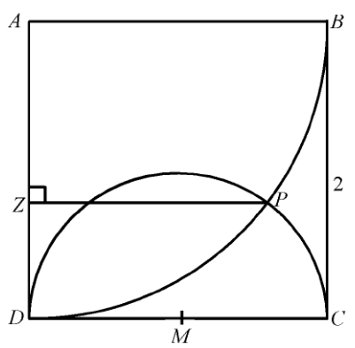

Question 6.
How many six-digit numbers are there in which the sum of the squares of the digits is 12?
(Note: the six-digit number cannot start with zero.)

Question 7.
If and $log_{8}b+log_{4}a^{2}=7.$ Find the value of S=a+b

Question 8.
The sum of the first six terms of a geometric sequence is 12, and the sum of the reciprocals of
these six terms is 20. Find the product of these six terms.

Question 9.
A circle with centre (1, 1) has a radius of 1 unit. If a point inside the circle is chosen at random, what is the probability that the y coordinate is more than twice the x coordinate? (Round your answer to the nearest tenth)
Question 10.
A 6 by 6 square lattice is formed by drilling holes in a wooden board. Three pegs are placed at random in this lattice. Find the probability that the three randomly chosen points of a 6 by 6 lattice will form a triangle (Round your answer to two decimal places)
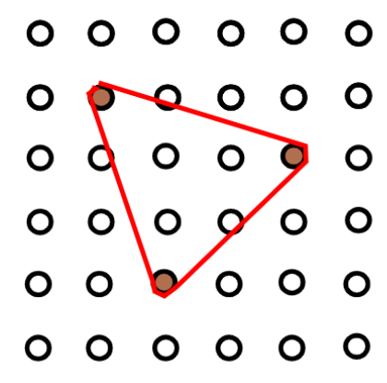
Question 11.
Let f satisfy the functional equation $2f(x)+3f\left(\frac{2x+29}{x-2}\right)=100x+140$
Find $f(8)$

Question 12.
Three judges for a talent quest have to vote publically on the three performers A, B and C, ranking
their order of preference. What is the probability that the judges vote so that two of them agree in their order of preference while the third differs?

Question 13.
By definition, Euler’s number (e) is defined as $\lim_{n→+∞}{{\left(1+\frac{1}{n}\right)}^{n}=e}$
which is approximately equal to 2.7128182846.
What is the value of $\lim_{n→+∞}{{\left(1+\frac{2}{n}\right)}^{n}}$

Question 14.
Find the limiting value of the series
$$\frac{3}{10}+\frac{21}{100}+\frac{117}{1000}+\frac{609}{10000}+...$$

Question 15.
An aquarium measures 20 cm in width, 30 cm in length, and 15 cm in depth. It is tilted along edge AB until the water just covers the end ABCD. At that moment, the water also covers $\frac{4}{5}$ ​ of the base. Find the depth of the water (in centimeters) when the aquarium is level.
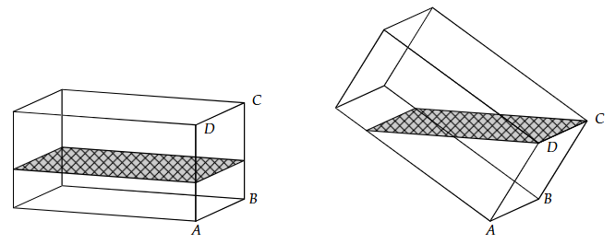
Question 16.
Two trains are moving toward each other on a long straight track. One train is traveling at 5 km/h, and the other at 3 km/h. When the two trains are 3 km apart, a mosquito starts flying from the front of the slower train toward the faster train. When it reaches the faster train, it immediately turns around and flies back toward the slower train. If, when the two trains are 1 km apart, the mosquito has just returned to the slower train, find the speed of the mosquito (in km/h).

Question 17.
A regular tetrahedron has four faces, four vertices, and six edges. Its edges are all equal, and each face is an equilateral triangle. A regular tetrahedron inscribed in a sphere is a tetrahedron whose vertices all lie on the surface of the sphere. Find the volume of the regular tetrahedron inscribed in a sphere of radius 1, rounded to one decimal place.
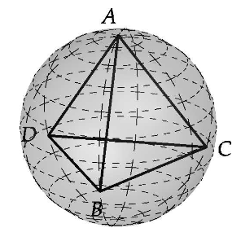

Question 18.
In the diagram ABCD is a unit square. The line segment PQ makes an angle θ with side AB and is a diameter of the shaded semicircle. The semicircle is tangent to the side BC of the square of the at point X. Determine the value of θ for which the area is maximum while still guaranteeing the the semicircle is entirely inside the square.
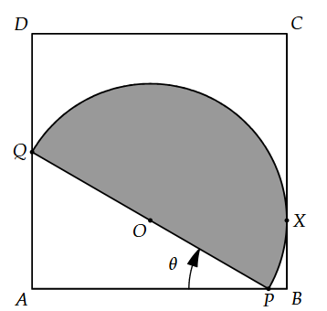

Question 19.
Five marbles of various sizes are placed in a conical funnel. Each marble is in contact with the adjacent marble(s) and with the funnel wall. The smallest marble has a radius of 8 mm. The largest marble has a radius of 18 mm. Determine the radius, measured in mm, of the middle marble.
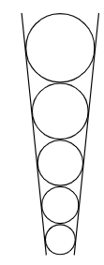

Question 20.
The diagram shows top and bottom views of a cylinder, with the crosshatched region representing the part covered with aluminum foil. The radius of the cylinder is 6 cm, and its height is 12 cm. On the top, the radii OA and OB form an angle of ∠AOB = 60°. On the bottom, the radii UM and UN form an angle of ∠NUM = 120°.
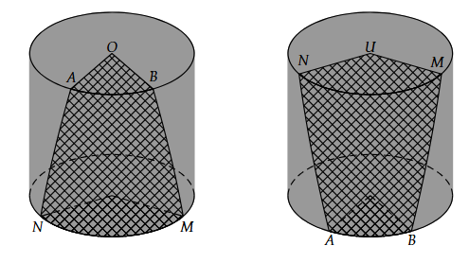
Find the total surface area of the part of the cylinder covered with aluminum foil.

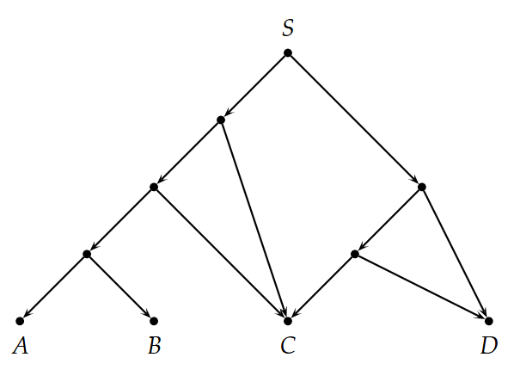
Question 21.
The map on the right shows a system of one-way trails in a park. A hiker starts at point S.
Whenever she reaches a junction with two paths, she flips a coin to decide whether to go left or right. Eventually, she will arrive at one of the destinations A, B, C, or D. Find the probability that she reaches point C.

Question 22.
Your telescope is initially pointed at the North Star. You lower the telescope by exactly 45°, and through it, you see a ship on the horizon. Then you rotate the telescope exactly 45° parallel to the horizon and see a lighthouse.
If you now rotate the telescope from the lighthouse back to the North Star, determine the number of degrees through which the telescope must be rotated.

Question 23.
As shown, the large unshaded circle is tangent to the semicircle at the point A and to the diameter of the semicircle at point B, the midpoint of the diameter. The two smaller unshaded circles are tangent to the semicircle, the diameter, and the large unshaded circle. What fraction of the semicircle is shaded.
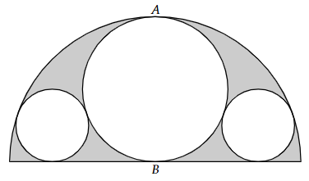

Question 24.
In the coordinate plane Oxy, let A and B be two points lying respectively on the graphs of the functions and such that the point C(3, 0) is the midpoint of the segment AB (as shown in the figure).
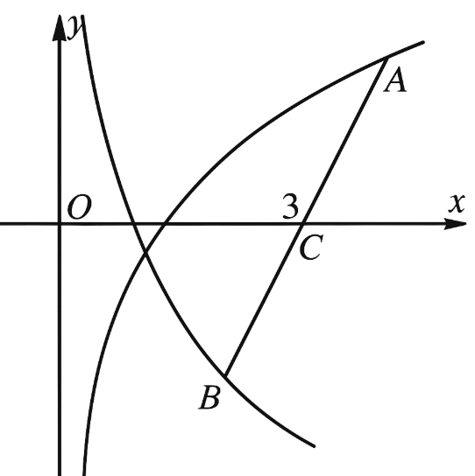
Find the area of triangle OAB. (Round your answer to the nearest hundredth.)

Question 25.
The number of cells in a yeast population cultured in a laboratory at time t is modeled by the formula where $(t≥0)(unit:hour).$ It is known that the function y = f '(t) represents the growth rate of the population at time t. When the growth rate of the population is greatest, how many thousand cells does the population have?

